Faculty myCoyote Portal View

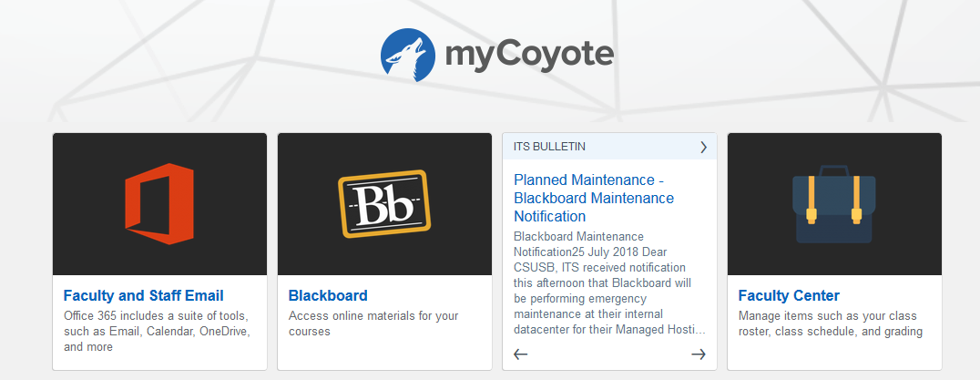

Faculty Center View
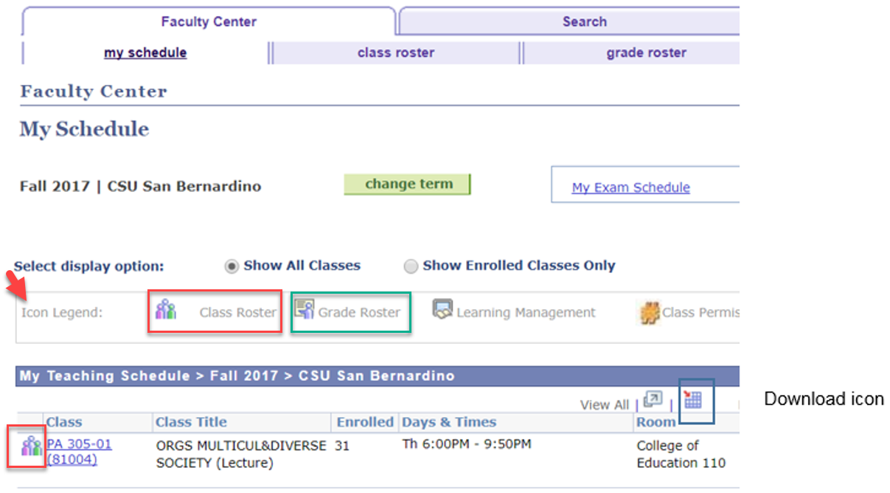
Make sure Cookies are not blocked to take advantage of the Download icon.

To take advantage of the Download icon, first navigate to the page you wish to download data. For example, the ‘Course Roster’. Select the ‘Course Roster’ icon first, the roster will open, then select the download icon.

Another great feature on the roster page is the ‘Include photos in list’ radio button. Once on the roster page, select the radio button ‘Include photos in list’ then select ‘View All’ to the right on the navigation header and student photos will appear. Please protect the privacy of our students at all times, do not print photos.

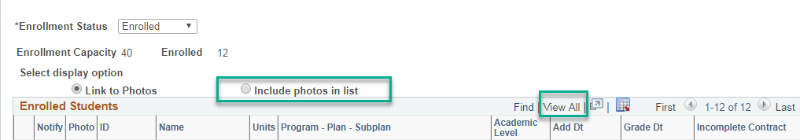
During the 8th week of classes, the Grade Roster icon will appear. An email notification is sent to all faculty informing users the icon is available.
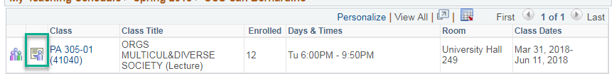

Student myCoyote Portal View – this page is helpful to know what some of your students see in the MyCoyote portal.

