Participation Roster
Participation is defined as attendance to an academically related activity.

Accessing the Participation Roster using CSUSB Faculty Center.

- Select the Class Roster for which you wish to record class participation.

NOTE: Please make sure the term and course are correct. If the term is incorrect, please select the “Change Term” button.
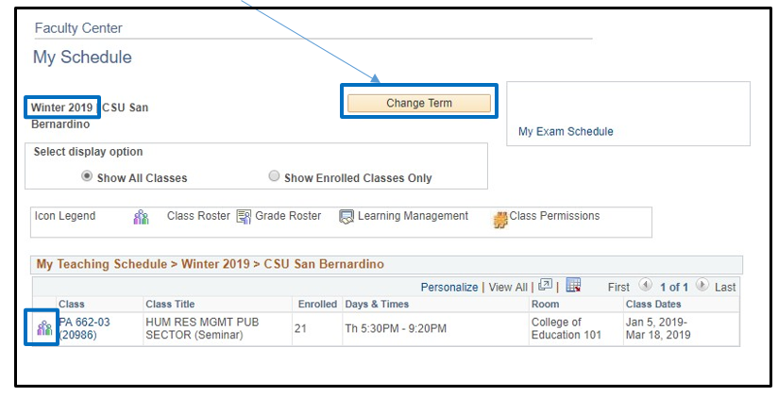
- Select the “Participation Confirmation” button.

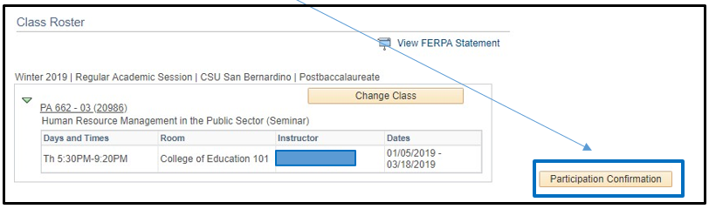

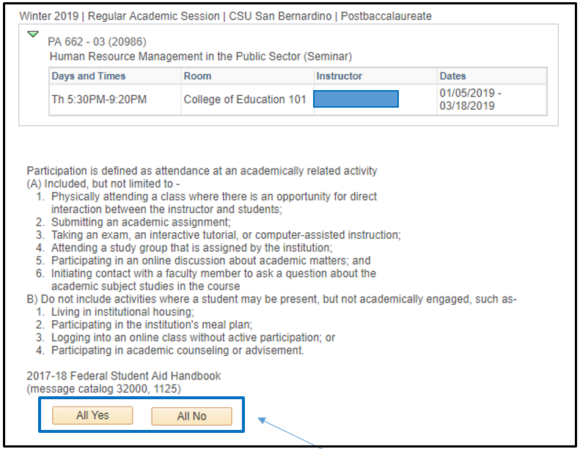

- You are able to set the Attendance Indicators to All Yes or All No by selecting the appropriate button or by updating each individual student as necessary (see examples below).

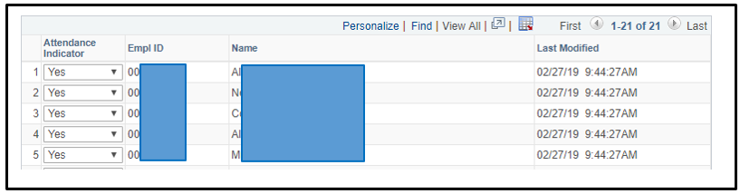
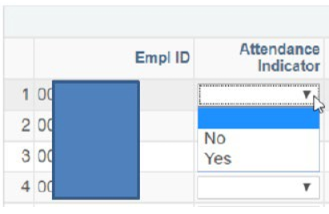

- If you wish to sort your roster by name instead of Empl ID, select the Name column and your students will be sorted by Last, First Name.

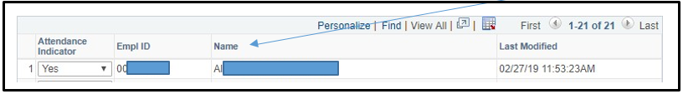

- Once all of the students Attendance Indicator has been selected, please click either “Apply” or “OK” and your Participation Roster will be saved.
NOTE: If you sorted your Participation Roster by name and decide to go back into the roster to make any adjustments, you will need to sort the roster again. Your name sort will not be saved.
- If you do not want to save your participation roster and would like to go back to the previous page, select “Cancel.”
